**Made in Abyss Season 2: Release, cast, plot**

**Made in Abyss** is a Japanese anime series grounded on the comic written by Akihito Tsukushi. Its first season was premiered in 2017 from July 7 to September 29. It’s first season left a great impression on the audience and won many awards. So, it’s obvious that weebs and otakus all around the world are waiting for its **second season**.

**Made in Abyss season 2: Release date**

According to sources production part for **season 2** is already completed and it was about to hit the viewers screen in 2020 but because of the pandemic its release was postponed and there’s no official confirmation on the same, when it’ll be released but however we can expect its release this year in **2021**.

**Made in Abyss season 2: cast**

The voice actors are going to return back in **season 2**. So, we don’t expect any new actor to take their role. Some of the actors who were there in *season 1* are:

|  |  |  |
| --- | --- | --- |
| Characters | Japanese voice actor | English voice actor |
| **Riko** | Miyu Tomita | Brittany Lauda |
| **Reg** | Mariya Ise | Luci Christian |
| **Nanachi** | Shiori Izawa | Brittney Karbowski |
| Mitty | Eri Kitamura | Monica Rial |
| Director | Yoko Somi | Julie Oliver- Touchstone |
| Jiruo | Taishi Murata | Daniel Regojo |
| Nat | Mutsumi Tamura | Shannon Emerick |
| Shiggy | Manami Numakura | Terri Doty |
| Kiyui | Manami Hanawa | Kalin Coates |
| Habolg | Tetsu Inada | John Swasey |
| Ozen | Sayaka Ohara | Christine Auten |
| Marulk | Aki Toyosaki | Kelley Peters |
| Lyza | Maaya Sakamoto | Shelley Calene-Black |
| Bondrewd | Toshiyuki Morikawa | David Harbold |

**Made in Abyss season 2: Plot**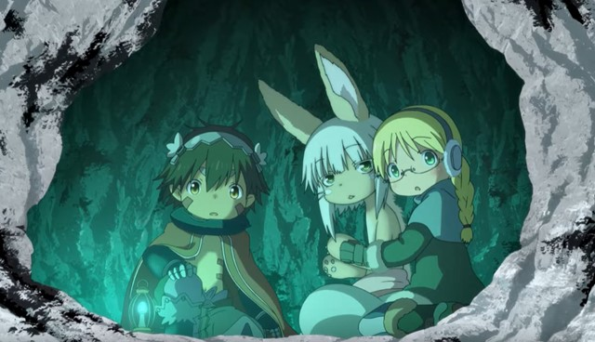

As per the sources, **second season** will be revolving around the protagonist of the anime like Riko, Reg, and Nanachi, who will work on discovering the new facts and truths of *Abyss* and will get deeper into that. They’ll be revealing the *sixth layer* of *Rico Abyss*. Rico will be seen diving into the deepest layer, visiting the *Hollow Village*, where she’ll be seen struggling to live her life and save her loving and dear ones. This’s a clear indication of the fact that viewers can anticipate so much thrill and adventure in ***season 2***.

Reiko will be on the mission to search her mother with the help of her best companion and her Robot dog, Reg. While looking for her mother, she gets trapped inside a deep place, *Abyss*, which is a very minacious and magical place completely filled up with dreadful scenes and plot. So, *second season* is going to be completely adventurous and mysterious. Till that time, you can watch *season 1* available on *Netflix*.